Data analytics project

Retail sales and profit analysis:

Problem statement:

The owner of the showroom wants to analyze the sales of his products and wants to calculate how much revenue he had earned .

Objective:

The objective of the project is to analyze the dataset , clean it and extract business insights and create a simple dashboard .

End results:

- Business insights:

Sales by region:

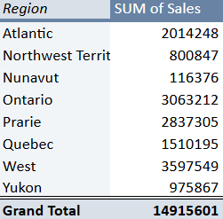

Sales by product category:

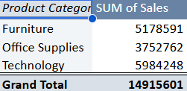

Top products By sales:

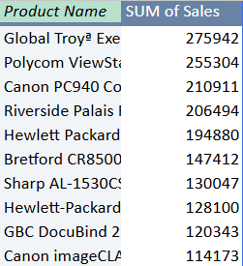

Profit by customer segment:

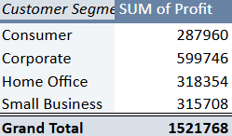

Sales by order priority:

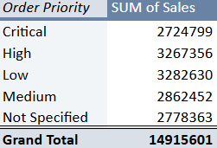

Monthly sales Trend:

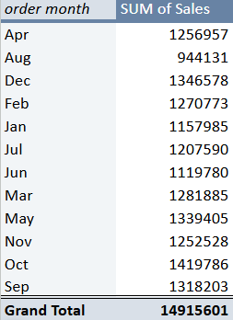

- Dashboard:

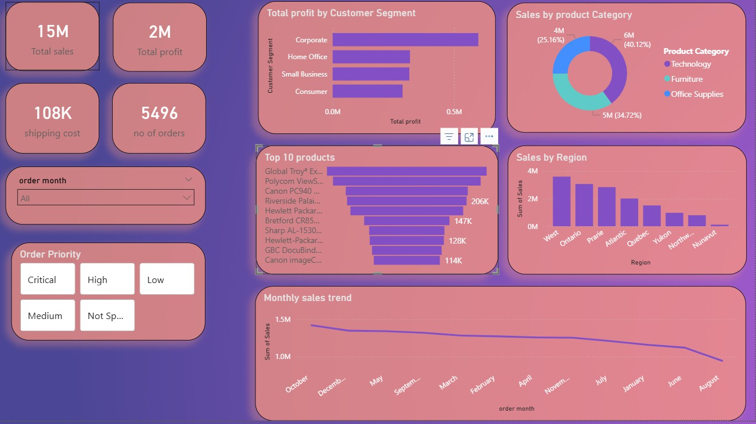
Questions Answered:

Which region generates the highest sales?

West region generates highest sales as compared to other regions

Which product category is the most profitable?

Technology category is the most profitable as the products like printers , copiers , video conferencing units are being sold in a higher number.

Which products generate the highest revenue?

- Global troy low back tilter
- Polycon videoconferencing unit
- Canon pc940 copier

- Riverside Lawyer Bookcase
- Hewlet Laserjet Copier
- Bretford Meetroom Furniture
- Sharp AL Digital Copier
- Hewlet Inkjet printer
- GBC Binding Machine
- Canon Advanced Copier

Which customer segment contributes the most Profit?

Corporate segment contributes the most profit as the products are sold in bulk quantity for corporate companies

What is the monthly sales trend?

At October month , there were higher sales of 1418974 as the no of orders were more (487) of products with higher prices. least sales taken place on August month of 944127 with 450 orders.

Conclusion:

With this , The whole dataset was analyzed with the extraction of business insights , creation of dashboard and answering the necessary questions which helps the client to understand the business problem and organize the products accordingly.

